Subject: IT 221 - IT ELECTIVE 3 – WEB SYSTEM & TECHNOLOGIES
Prof: Leo P. Paliuanan
leopaliuanan@csu.edu.ph

UNIT 3 – Deeper to HTML

Topics:

- Head  - attributes  - headings  - paragraphs  - styles  - formatting  - comments  - colors  - css  - links | - images  - favicon  - tables  - lists  - block and inline  - classes  - file paths  - layout  - responsive

At the end of this course, you will be able to:

- use HTML basics and elements
- use HTML in designing webpages
- use HTML to create a simple website

Course content

An HTML element is defined by a start tag, some content, and an end tag.

HTML Structures and Elements
The HTML element is everything from the start tag to the end tag:
<tagname>Content goes here...</tagname>
Examples of some HTML elements:
<h1>My First Heading</h1>
<p>My first paragraph.</p>
Start tag | Element content | End tag
<h1> | My First Heading | </h1>
<p> | My first paragraph. | </p>
<br> | none | none
Note: Some HTML elements have no content (like the <br> element). These elements are called empty elements. Empty elements do not have an end tag!

Nested HTML Elements
HTML elements can be nested (this means that elements can contain other elements).
All HTML documents consist of nested HTML elements.
The following example contains four HTML elements (<html>, <body>, <h1> and <p>):

Example
<!DOCTYPE html>
<html>
<body>
<h1>My First Heading</h1>
<p>My first paragraph.</p>
</body>
</html>

Example Explained
The <html> element is the root element and it defines the whole HTML document.
It has a start tag <html> and an end tag </html>.
Then, inside the <html> element there is a <body> element:
<body>
<h1>My First Heading</h1>
<p>My first paragraph.</p>
</body>
The <body> element defines the document's body.
It has a start tag <body> and an end tag </body>.
Then, inside the <body> element there are two other elements: <h1> and <p>:
<h1>My First Heading</h1>
<p>My first paragraph.</p>
The <h1> element defines a heading.
It has a start tag <h1> and an end tag </h1>:
<h1>My First Heading</h1>
The <p> element defines a paragraph.
It has a start tag <p> and an end tag </p>:
<p>My first paragraph.</p>

Never Skip the End Tag
Some HTML elements will display correctly, even if you forget the end tag:

Example
<html>
<body>
<p>This is a paragraph
<p>This is a paragraph
</body>
</html>
However, never rely on this! Unexpected results and errors may occur if you forget the end tag!

Empty HTML Elements
HTML elements with no content are called empty elements.
The <br> tag defines a line break, and is an empty element without a closing tag:

Example
<p>This is a <br> paragraph with a line break.</p>

HTML is Not Case Sensitive
HTML tags are not case sensitive: <P> means the same as <p>.
The HTML standard does not require lowercase tags, but W3C recommends lowercase in HTML, and demands lowercase for stricter document types like XHTML.

      - Attributes
HTML attributes provide additional information about HTML elements.

HTML Attributes
- All HTML elements can have attributes
- Attributes provide additional information about elements
- Attributes are always specified in the start tag
- Attributes usually come in name/value pairs like: name="value"

The href Attribute
The <a> tag defines a hyperlink. The href attribute specifies the URL of the page the link goes to:

Example
<a href="https://www.w3schools.com">Visit W3Schools</a>

The src Attribute
The <img> tag is used to embed an image in an HTML page. The src attribute specifies the path to the image to be displayed:

Example
<img src="img_girl.jpg">

There are two ways to specify the URL in the src attribute:
1. Absolute URL - Links to an external image that is hosted on another website. Example: src="https://www.w3schools.com/images/img_girl.jpg".
Notes: External images might be under copyright. If you do not get permission to use it, you may be in violation of copyright laws. In addition, you cannot control external images; it can suddenly be removed or changed.
2. Relative URL - Links to an image that is hosted within the website. Here, the URL does not include the domain name. If the URL begins without a slash, it will be relative to the current page. Example: src="img_girl.jpg". If the URL begins with a slash, it will be relative to the domain. Example: src="/images/img_girl.jpg".
Tip: It is almost always best to use relative URLs. They will not break if you change domain.

The width and height Attributes
The <img> tag should also contain the width and height attributes, which specify the width and height of the image (in pixels):

Example
<img src="img_girl.jpg" width="500" height="600">

The alt Attribute
The required alt attribute for the <img> tag specifies an alternate text for an image, if the image for some reason cannot be displayed. This can be due to a slow connection, or an error in the src attribute, or if the user uses a screen reader.

Example
<img src="img_girl.jpg" alt="Girl with a jacket">

Example
See what happens if we try to display an image that does not exist:
<img src="img_typo.jpg" alt="Girl with a jacket">

The style Attribute
The style attribute is used to add styles to an element, such as color, font, size, and more.

Example
<p style="color:red;">This is a red paragraph.</p>

The lang Attribute
You should always include the lang attribute inside the <html> tag, to declare the language of the Web page. This is meant to assist search engines and browsers.
The following example specifies English as the language:
<!DOCTYPE html>
<html lang="en">
<body>
...
</body>
</html>
Country codes can also be added to the language code in the lang attribute. So, the first two characters define the language of the HTML page, and the last two characters define the country.
The following example specifies English as the language and United States as the country:
<!DOCTYPE html>
<html lang="en-US">
<body>
...
</body>
</html>

The title Attribute
The title attribute defines some extra information about an element.
The value of the title attribute will be displayed as a tooltip when you mouse over the element:

Example
<p title="I'm a tooltip">This is a paragraph.</p>

We Suggest: Always Use Lowercase Attributes
The HTML standard does not require lowercase attribute names.
The title attribute (and all other attributes) can be written with uppercase or lowercase like title or TITLE.
However, W3C recommends lowercase attributes in HTML, and demands lowercase attributes for stricter document types like XHTML.
At W3Schools we always use lowercase attribute names.

We Suggest: Always Quote Attribute Values
The HTML standard does not require quotes around attribute values.
However, W3C recommends quotes in HTML, and demands quotes for stricter document types like XHTML.

Good:
<a href="https://www.w3schools.com/html/">Visit our HTML tutorial</a>

Bad:
<a href=https://www.w3schools.com/html/>Visit our HTML tutorial</a>
Sometimes you have to use quotes. This example will not display the title attribute correctly, because it contains a space:

Example
<p title=About W3Schools>

Single or Double Quotes?
Double quotes around attribute values are the most common in HTML, but single quotes can also be used.
In some situations, when the attribute value itself contains double quotes, it is necessary to use single quotes:
<p title='John "ShotGun" Nelson'>
Or vice versa:
<p title="John 'ShotGun' Nelson">

Chapter Summary
- All HTML elements can have attributes
- The href attribute of <a> specifies the URL of the page the link goes to
- The src attribute of <img> specifies the path to the image to be displayed
- The width and height attributes of <img> provide size information for images
- The alt attribute of <img> provides an alternate text for an image
- The style attribute is used to add styles to an element, such as color, font, size, and more
- The lang attribute of the <html> tag declares the language of the Web page
- The title attribute defines some extra information about an element
      - Headings
HTML headings are titles or subtitles that you want to display on a webpage.

Example
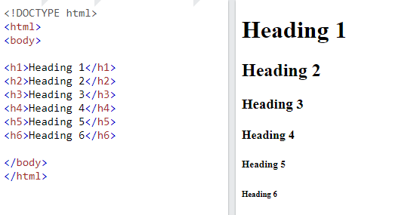

HTML Headings
HTML headings are defined with the <h1> to <h6> tags.
<h1> defines the most important heading. <h6> defines the least important heading.

Example
<h1>Heading 1</h1>
<h2>Heading 2</h2>
<h3>Heading 3</h3>
<h4>Heading 4</h4>
<h5>Heading 5</h5>
<h6>Heading 6</h6>

Headings Are Important
Search engines use the headings to index the structure and content of your web pages.
Users often skim a page by its headings. It is important to use headings to show the document structure.
<h1> headings should be used for main headings, followed by <h2> headings, then the less important <h3>, and so on.
Note: Use HTML headings for headings only. Don't use headings to make text BIG or bold.

Bigger Headings
Each HTML heading has a default size. However, you can specify the size for any heading with the style attribute, using the CSS font-size property:

Example
<h1 style="font-size:60px;">Heading 1</h1>

  - Paragraphs
A paragraph always starts on a new line, and is usually a block of text.

HTML Paragraphs
The HTML <p> element defines a paragraph.
A paragraph always starts on a new line, and browsers automatically add some white space (a margin) before and after a paragraph.

Example
<p>This is a paragraph.</p>
<p>This is another paragraph.</p>

HTML Display
You cannot be sure how HTML will be displayed.
Large or small screens, and resized windows will create different results.
With HTML, you cannot change the display by adding extra spaces or extra lines in your HTML code.
The browser will automatically remove any extra spaces and lines when the page is displayed:

Example
<p>
This paragraph
contains a lot of lines
in the source code,
but the browser
ignores it.
</p>
<p>
This paragraph
contains a lot of spaces
in the source code,
but the browser
ignores it.
</p>

HTML Horizontal Rules
The <hr> tag defines a thematic break in an HTML page, and is most often displayed as a horizontal rule.
The <hr> element is used to separate content (or define a change) in an HTML page:

Example
<h1>This is heading 1</h1>
<p>This is some text.</p>
<hr>
<h2>This is heading 2</h2>
<p>This is some other text.</p>
<hr>

The <hr> tag is an empty tag, which means that it has no end tag.

HTML Line Breaks
The HTML <br> element defines a line break.
Use <br> if you want a line break (a new line) without starting a new paragraph:

Example
<p>This is<br>a paragraph<br>with line breaks.</p>
The <br> tag is an empty tag, which means that it has no end tag.

The Poem Problem
This poem will display on a single line:

Example
<p>
My Bonnie lies over the ocean.
My Bonnie lies over the sea.
My Bonnie lies over the ocean.
Oh, bring back my Bonnie to me.
</p>

Solution - The HTML <pre> Element
The HTML <pre> element defines preformatted text.
The text inside a <pre> element is displayed in a fixed-width font (usually Courier), and it preserves both spaces and line breaks:

Example
<pre>
My Bonnie lies over the ocean.
My Bonnie lies over the sea.
My Bonnie lies over the ocean.
Oh, bring back my Bonnie to me.
</pre>

  - Styles

The HTML style attribute is used to add styles to an element, such as color, font, size, and more.

Example

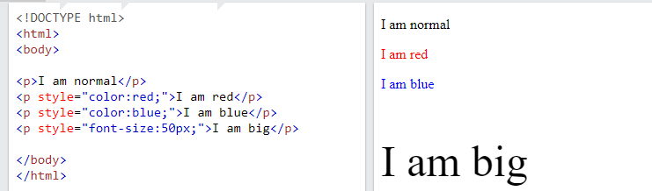

The HTML Style Attribute
Setting the style of an HTML element, can be done with the style attribute.
The HTML style attribute has the following syntax:
<tagname style="property:value;">
The property is a CSS property. The value is a CSS value.

Background Color
The CSS background-color property defines the background color for an HTML element.

Example
Set the background color for a page to powderblue:
<body style="background-color:powderblue;">
<h1>This is a heading</h1>
<p>This is a paragraph.</p>
</body>

Example
Set background color for two different elements:
<body>
<h1 style="background-color:powderblue;">This is a heading</h1>
<p style="background-color:tomato;">This is a paragraph.</p>
</body>

Text Color
The CSS color property defines the text color for an HTML element:

Example
<h1 style="color:blue;">This is a heading</h1>
<p style="color:red;">This is a paragraph.</p>

Fonts
The CSS font-family property defines the font to be used for an HTML element:

Example
<h1 style="font-family:verdana;">This is a heading</h1>
<p style="font-family:courier;">This is a paragraph.</p>

Text Size
The CSS font-size property defines the text size for an HTML element:

Example
<h1 style="font-size:300%;">This is a heading</h1>
<p style="font-size:160%;">This is a paragraph.</p>

Text Alignment
The CSS text-align property defines the horizontal text alignment for an HTML element:

Example
<h1 style="text-align:center;">Centered Heading</h1>
<p style="text-align:center;">Centered paragraph.</p>

Chapter Summary
- Use the style attribute for styling HTML elements
- Use background-color for background color
- Use color for text colors
- Use font-family for text fonts
- Use font-size for text sizes
- Use text-align for text alignment

  - Formatting

HTML Text Formatting
HTML contains several elements for defining text with a special meaning.

Example
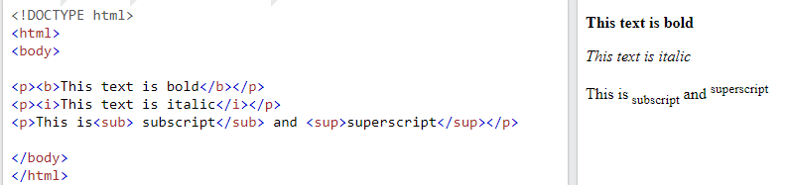

HTML Formatting Elements
Formatting elements were designed to display special types of text:
- <b> - Bold text
- <strong> - Important text
- <i> - Italic text
- <em> - Emphasized text
- <mark> - Marked text
- <small> - Smaller text
- <del> - Deleted text
- <ins> - Inserted text
- <sub> - Subscript text
- <sup> - Superscript text

HTML <b> and <strong> Elements
The HTML <b> element defines bold text, without any extra importance.

Example
<b>This text is bold</b>
The HTML <strong> element defines text with strong importance. The content inside is typically displayed in bold.

Example
<strong>This text is important!</strong>

HTML <i> and <em> Elements
The HTML <i> element defines a part of text in an alternate voice or mood. The content inside is typically displayed in italic.
Tip: The <i> tag is often used to indicate a technical term, a phrase from another language, a thought, a ship name, etc.

Example
<i>This text is italic</i>
The HTML <em> element defines emphasized text. The content inside is typically displayed in italic.
Tip: A screen reader will pronounce the words in <em> with an emphasis, using verbal stress.

Example
<em>This text is emphasized</em>

HTML <small> Element
The HTML <small> element defines smaller text:

Example
<small>This is some smaller text.</small>

HTML <mark> Element
The HTML <mark> element defines text that should be marked or highlighted:

Example
<p>Do not forget to buy <mark>milk</mark> today.</p>

HTML <del> Element
The HTML <del> element defines text that has been deleted from a document. Browsers will usually strike a line through deleted text:

Example
<p>My favorite color is <del>blue</del> red.</p>

HTML <ins> Element
The HTML <ins> element defines a text that has been inserted into a document. Browsers will usually underline inserted text:

Example
<p>My favorite color is <del>blue</del> <ins>red</ins>.</p>

HTML <sub> Element
The HTML <sub> element defines subscript text. Subscript text appears half a character below the normal line, and is sometimes rendered in a smaller font. Subscript text can be used for chemical formulas, like H₂O:

Example
<p>This is <sub>subscripted</sub> text.</p>

HTML <sup> Element
The HTML <sup> element defines superscript text. Superscript text appears half a character above the normal line, and is sometimes rendered in a smaller font. Superscript text can be used for footnotes, like WWW^{[1]}:

Example
<p>This is <sup>superscripted</sup> text.</p>

  - Comments

HTML Comments
HTML comments are not displayed in the browser, but they can help document your HTML source code.

HTML Comment Tag
You can add comments to your HTML source by using the following syntax:
<!-- Write your comments here -->
Notice that there is an exclamation point (!) in the start tag, but not in the end tag.
Note: Comments are not displayed by the browser, but they can help document your HTML source code.

Add Comments
With comments you can place notifications and reminders in your HTML code:

Example
<!-- This is a comment -->
<p>This is a paragraph.</p>
<!-- Remember to add more information here -->

Hide Content
Comments can be used to hide content.
This can be helpful if you hide content temporarily:

Example
<p>This is a paragraph.</p>
<!-- <p>This is another paragraph </p> -->
<p>This is a paragraph too.</p>
You can also hide more than one line. Everything between the <!-- and the --> will be hidden from the display.

Example
Hide a section of HTML code:
<p>This is a paragraph.</p>
<!--
<p>Look at this cool image:</p>
<img border="0" src="pic_trulli.jpg" alt="Trulli">
-->
<p>This is a paragraph too.</p>
Comments are also great for debugging HTML, because you can comment out HTML lines of code, one at a time, to search for errors.

Hide Inline Content
Comments can be used to hide parts in the middle of the HTML code.

Example
Hide a part of a paragaph:
<p>This <!-- great text --> is a paragraph.</p>

  - Colors

HTML Colors
HTML colors are specified with predefined color names, or with RGB, HEX, HSL, RGBA, or HSLA values.

Color Names
In HTML, a color can be specified by using a color name:
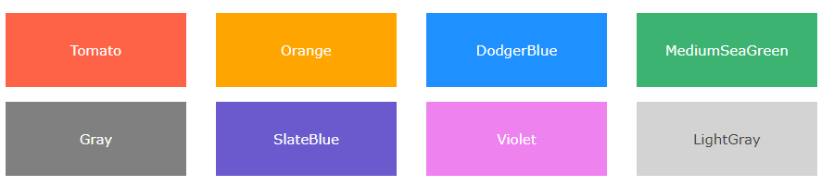
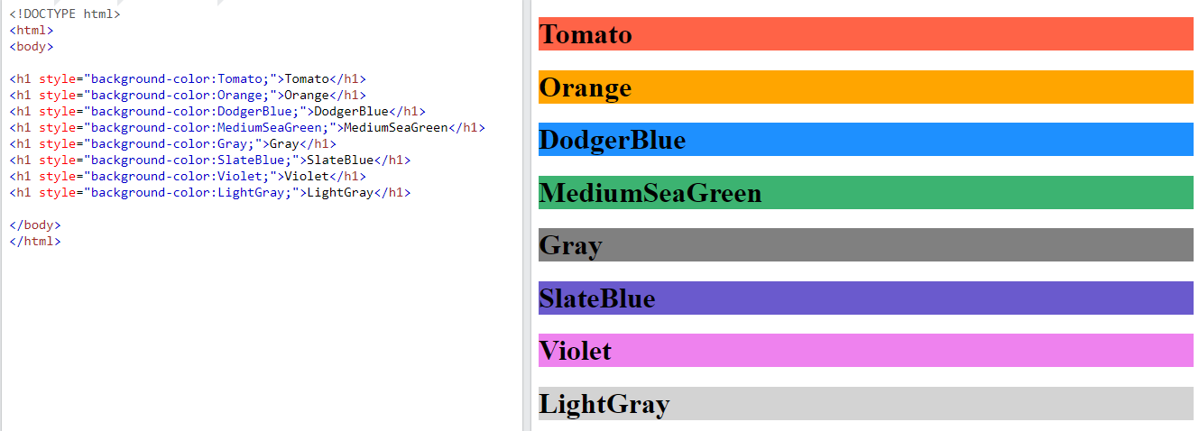

Background Color
You can set the background color for HTML elements:
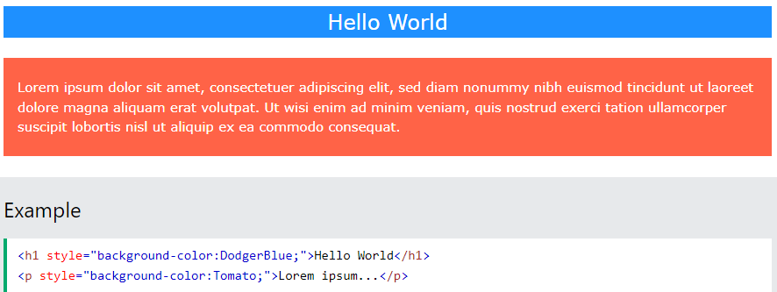

Text Color
You can set the color of text:
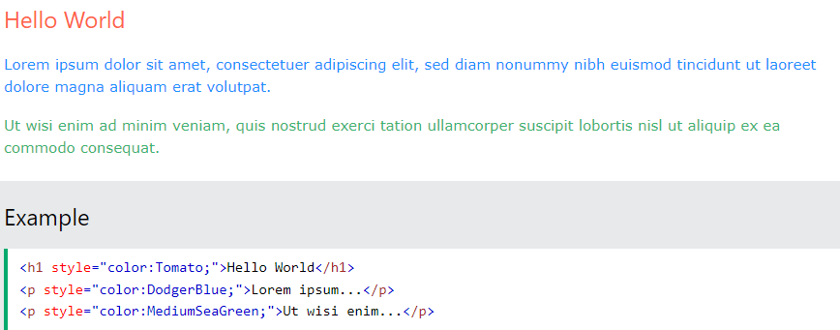
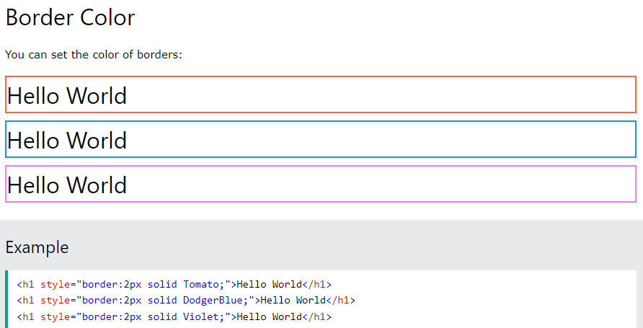

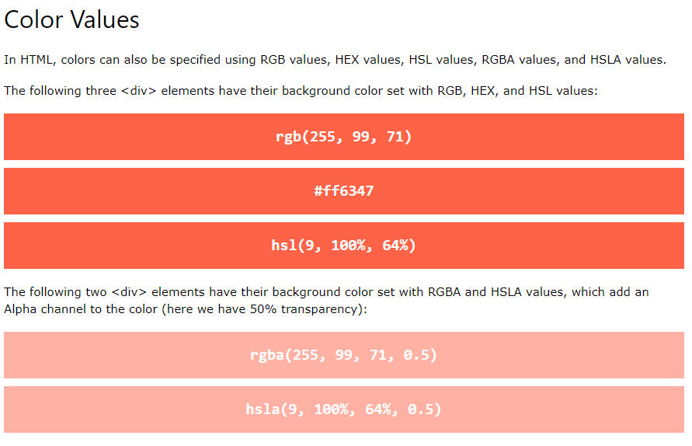

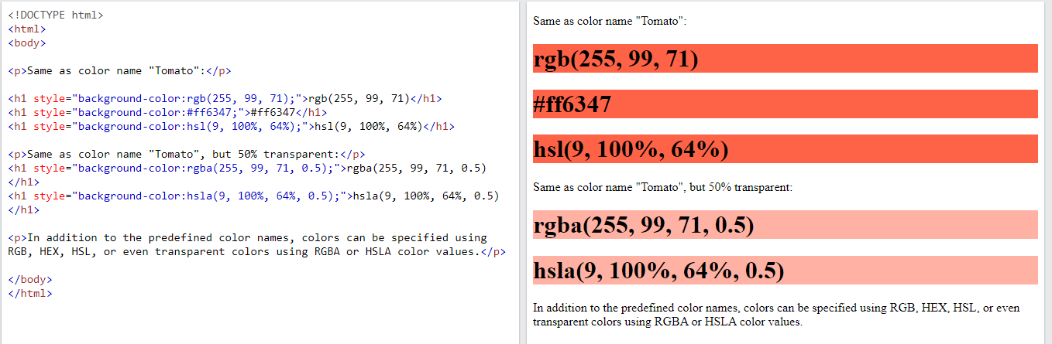

  - HTML CSS

HTML Styles - CSS
CSS stands for Cascading Style Sheets.
CSS saves a lot of work. It can control the layout of multiple web pages all at once.
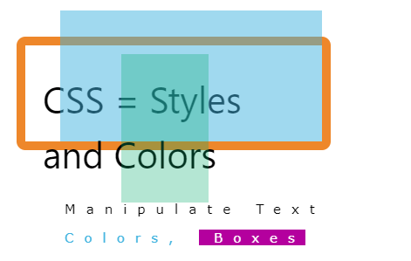

What is CSS?
Cascading Style Sheets (CSS) is used to format the layout of a webpage.
With CSS, you can control the color, font, the size of text, the spacing between elements, how elements are positioned and laid out, what background images or background colors are to be used, different displays for different devices and screen sizes, and much more!
Tip: The word cascading means that a style applied to a parent element will also apply to all children elements within the parent. So, if you set the color of the body text to "blue", all headings, paragraphs, and other text elements within the body will also get the same color (unless you specify something else)!

Using CSS
CSS can be added to HTML documents in 3 ways:
- Inline - by using the style attribute inside HTML elements
- Internal - by using a <style> element in the <head> section
- External - by using a <link> element to link to an external CSS file
The most common way to add CSS, is to keep the styles in external CSS files. However, in this tutorial we will use inline and internal styles, because this is easier to demonstrate, and easier for you to try it yourself.

Inline CSS
An inline CSS is used to apply a unique style to a single HTML element.
An inline CSS uses the style attribute of an HTML element.
The following example sets the text color of the <h1> element to blue, and the text color of the <p> element to red:

Example
<h1 style="color:blue;">A Blue Heading</h1>
<p style="color:red;">A red paragraph.</p>

Internal CSS
An internal CSS is used to define a style for a single HTML page.
An internal CSS is defined in the <head> section of an HTML page, within a <style> element.
The following example sets the text color of ALL the <h1> elements (on that page) to blue, and the text color of ALL the <p> elements to red. In addition, the page will be displayed with a "powderblue" background color:

Example
<!DOCTYPE html>
<html>
<head>
<style>
body {background-color: powderblue;}
h1 {color: blue;}
p {color: red;}
</style>
</head>
<body>
<h1>This is a heading</h1>
<p>This is a paragraph.</p>
</body>
</html>

External CSS
An external style sheet is used to define the style for many HTML pages.
To use an external style sheet, add a link to it in the <head> section of each HTML page:

Example
<!DOCTYPE html>
<html>
<head>
<link rel="stylesheet" href="styles.css">
</head>
<body>
<h1>This is a heading</h1>
<p>This is a paragraph.</p>
</body>
</html>
The external style sheet can be written in any text editor. The file must not contain any HTML code, and must be saved with a .css extension.
Here is what the "styles.css" file looks like:

"styles.css":
body {
background-color: powderblue;
}
h1 {
color: blue;
}
p {
color: red;
}
Tip: With an external style sheet, you can change the look of an entire web site, by changing one file!

CSS Colors, Fonts and Sizes
Here, we will demonstrate some commonly used CSS properties. You will learn more about them later.
The CSS color property defines the text color to be used.
The CSS font-family property defines the font to be used.
The CSS font-size property defines the text size to be used.

Example
Use of CSS color, font-family and font-size properties:
<!DOCTYPE html>
<html>
<head>
<style>
h1 {
color: blue;
font-family: verdana;
font-size: 300%;
}
p {
color: red;
font-family: courier;
font-size: 160%;
}
</style>
</head>
<body>
<h1>This is a heading</h1>
<p>This is a paragraph.</p>
</body>
</html>

CSS Border
The CSS border property defines a border around an HTML element.
Tip: You can define a border for nearly all HTML elements.

Example
Use of CSS border property:
p {
border: 2px solid powderblue;
}

CSS Padding
The CSS padding property defines a padding (space) between the text and the border.

Example
Use of CSS border and padding properties:
p {
border: 2px solid powderblue;
padding: 30px;
}

CSS Margin
The CSS margin property defines a margin (space) outside the border.

Example
Use of CSS border and margin properties:
p {
border: 2px solid powderblue;
margin: 50px;
}

Link to External CSS
External style sheets can be referenced with a full URL or with a path relative to the current web page.

Example
This example uses a full URL to link to a style sheet:
<link rel="stylesheet" href="https://www.w3schools.com/html/styles.css">

Example
This example links to a style sheet located in the html folder on the current web site:
<link rel="stylesheet" href="/html/styles.css">

Chapter Summary
- Use the HTML style attribute for inline styling
- Use the HTML <style> element to define internal CSS
- Use the HTML <link> element to refer to an external CSS file
- Use the HTML <head> element to store <style> and <link> elements
- Use the CSS color property for text colors
- Use the CSS font-family property for text fonts
- Use the CSS font-size property for text sizes
- Use the CSS border property for borders
- Use the CSS padding property for space inside the border
- Use the CSS margin property for space outside the border
  - Links

HTML Links
Links are found in nearly all web pages. Links allow users to click their way from page to page.

HTML Links - Hyperlinks
HTML links are hyperlinks.
You can click on a link and jump to another document.
When you move the mouse over a link, the mouse arrow will turn into a little hand.
Note: A link does not have to be text. A link can be an image or any other HTML element!

HTML Links - Syntax
The HTML <a> tag defines a hyperlink. It has the following syntax:
<a href="url">link text</a>
The most important attribute of the <a> element is the href attribute, which indicates the link's destination.
The link text is the part that will be visible to the reader.
Clicking on the link text, will send the reader to the specified URL address.

Example
This example shows how to create a link to W3Schools.com:
<a href="https://www.w3schools.com/">Visit W3Schools.com!</a>
By default, links will appear as follows in all browsers:
- An unvisited link is underlined and blue
- A visited link is underlined and purple
- An active link is underlined and red
Tip: Links can of course be styled with CSS, to get another look!

HTML Links - The target Attribute
By default, the linked page will be displayed in the current browser window. To change this, you must specify another target for the link.
The target attribute specifies where to open the linked document.
The target attribute can have one of the following values:
- _self - Default. Opens the document in the same window/tab as it was clicked
- _blank - Opens the document in a new window or tab
- _parent - Opens the document in the parent frame
- _top - Opens the document in the full body of the window

Example
Use target="_blank" to open the linked document in a new browser window or tab:
<a href="https://www.w3schools.com/" target="_blank">Visit W3Schools!</a>

Absolute URLs vs. Relative URLs
Both examples above are using an absolute URL (a full web address) in the href attribute.
A local link (a link to a page within the same website) is specified with a relative URL (without the "https://www" part):

Example
<h2>Absolute URLs</h2>
<p><a href="https://www.w3.org/">W3C</a></p>
<p><a href="https://www.google.com/">Google</a></p>
<h2>Relative URLs</h2>
<p><a href="html_images.asp">HTML Images</a></p>
<p><a href="/css/default.asp">CSS Tutorial</a></p>

HTML Links - Use an Image as a Link
To use an image as a link, just put the <img> tag inside the <a> tag:

Example
<a href="default.asp">
<img src="smiley.gif" alt="HTML tutorial" style="width:42px;height:42px;">
</a>

Link to an Email Address
Use mailto: inside the href attribute to create a link that opens the user's email program (to let them send a new email):

Example
<a href="mailto:someone@example.com">Send email</a>

Button as a Link
To use an HTML button as a link, you have to add some JavaScript code.
JavaScript allows you to specify what happens at certain events, such as a click of a button:

Example
<button onclick="document.location='default.asp'">HTML Tutorial</button>

Link Titles
The title attribute specifies extra information about an element. The information is most often shown as a tooltip text when the mouse moves over the element.

Example
<a href="https://www.w3schools.com/html/" title="Go to W3Schools HTML section">Visit our HTML Tutorial</a>

More on Absolute URLs and Relative URLs

Example
Use a full URL to link to a web page:
<a href="https://www.w3schools.com/html/default.asp">HTML tutorial</a>

Example
Link to a page located in the html folder on the current web site:
<a href="/html/default.asp">HTML tutorial</a>

Chapter Summary
- Use the <a> element to define a link
- Use the href attribute to define the link address
- Use the target attribute to define where to open the linked document
- Use the <img> element (inside <a>) to use an image as a link
- Use the mailto: scheme inside the href attribute to create a link that opens the user's email program

HTML Link Tags
Tag | Description
<a> | Defines a hyperlink

HTML Link Colors
By default, a link will appear like this (in all browsers):
- An unvisited link is underlined and blue
- A visited link is underlined and purple
- An active link is underlined and red
You can change the link state colors, by using CSS:

Example
Here, an unvisited link will be green with no underline. A visited link will be pink with no underline. An active link will be yellow and underlined. In addition, when mousing over a link (a:hover) it will become red and underlined:
<style>
a:link {
color: green;
background-color: transparent;
text-decoration: none;
}
a:visited {
color: pink;
background-color: transparent;
text-decoration: none;
}
a:hover {
color: red;
background-color: transparent;
text-decoration: underline;
}
a:active {
color: yellow;
background-color: transparent;
text-decoration: underline;
}
</style>

Link Buttons
A link can also be styled as a button, by using CSS:
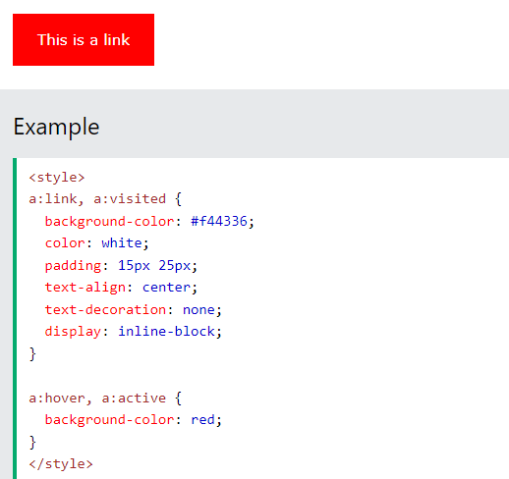

  - Images

HTML Images
Images can improve the design and the appearance of a web page.

Example
<img src="pic_trulli.jpg" alt="Italian Trulli">

HTML Images Syntax
The HTML <img> tag is used to embed an image in a web page.
Images are not technically inserted into a web page; images are linked to web pages. The <img> tag creates a holding space for the referenced image.
The <img> tag is empty, it contains attributes only, and does not have a closing tag.
The <img> tag has two required attributes:
- src - Specifies the path to the image
- alt - Specifies an alternate text for the image

Syntax
<img src="url" alt="alternatetext">

The src Attribute
The required src attribute specifies the path (URL) to the image.
Note: When a web page loads, it is the browser, at that moment, that gets the image from a web server and inserts it into the page. Therefore, make sure that the image actually stays in the same spot in relation to the web page, otherwise your visitors will get a broken link icon. The broken link icon and the alt text are shown if the browser cannot find the image.

Example
<img src="img_chania.jpg" alt="Flowers in Chania">

The alt Attribute
The required alt attribute provides an alternate text for an image, if the user for some reason cannot view it (because of slow connection, an error in the src attribute, or if the user uses a screen reader).
The value of the alt attribute should describe the image:

Example
<img src="img_chania.jpg" alt="Flowers in Chania">
If a browser cannot find an image, it will display the value of the alt attribute:

Example
<img src="wrongname.gif" alt="Flowers in Chania">

Image Size - Width and Height
You can use the style attribute to specify the width and height of an image.

Example
<img src="img_girl.jpg" alt="Girl in a jacket" style="width:500px;height:600px;">
Alternatively, you can use the width and height attributes:

Example
<img src="img_girl.jpg" alt="Girl in a jacket" width="500" height="600">
The width and height attributes always define the width and height of the image in pixels.
Note: Always specify the width and height of an image. If width and height are not specified, the web page might flicker while the image loads.

Width and Height, or Style?
The width, height, and style attributes are all valid in HTML.
However, we suggest using the style attribute. It prevents styles sheets from changing the size of images:

Example
<!DOCTYPE html>
<html>
<head>
<style>
img {
width: 100%;
}
</style>
</head>
<body>
<img src="html5.gif" alt="HTML5 Icon" width="128" height="128">
<img src="html5.gif" alt="HTML5 Icon" style="width:128px;height:128px;">
</body>
</html>

Images in Another Folder
If you have your images in a sub-folder, you must include the folder name in the src attribute:

Example
<img src="/images/html5.gif" alt="HTML5 Icon" style="width:128px;height:128px;">

Images on Another Server/Website
Some web sites point to an image on another server.
To point to an image on another server, you must specify an absolute (full) URL in the src attribute:

Example
<img src="https://www.w3schools.com/images/w3schools_green.jpg" alt="W3Schools.com">
Notes on external images: External images might be under copyright. If you do not get permission to use it, you may be in violation of copyright laws. In addition, you cannot control external images; they can suddenly be removed or changed.

Animated Images
HTML allows animated GIFs:

Example
<img src="programming.gif" alt="Computer Man" style="width:48px;height:48px;">

Image as a Link
To use an image as a link, put the <img> tag inside the <a> tag:

Example
<a href="default.asp">
<img src="smiley.gif" alt="HTML tutorial" style="width:42px;height:42px;">

Image Floating
Use the CSS float property to let the image float to the right or to the left of a text:

Example
<p><img src="smiley.gif" alt="Smiley face" style="float:right;width:42px;height:42px;">
The image will float to the right of the text.</p>
<p><img src="smiley.gif" alt="Smiley face" style="float:left;width:42px;height:42px;">
The image will float to the left of the text.</p>

Common Image Formats
Here are the most common image file types, which are supported in all browsers (Chrome, Edge, Firefox, Safari, Opera):
Abbreviation | File Format | File Extension
APNG | Animated Portable Network Graphics | .apng
GIF | Graphics Interchange Format | .gif
ICO | Microsoft Icon | .ico, .cur
JPEG | Joint Photographic Expert Group image | .jpg, .jpeg, .jfif, .pjpeg, .pjp
PNG | Portable Network Graphics | .png
SVG | Scalable Vector Graphics | .svg

Chapter Summary
- Use the HTML <img> element to define an image
- Use the HTML src attribute to define the URL of the image
- Use the HTML alt attribute to define an alternate text for an image, if it cannot be displayed
- Use the HTML width and height attributes or the CSS width and height properties to define the size of the image
- Use the CSS float property to let the image float to the left or to the right

HTML Background Images
A background image can be specified for almost any HTML element.

Background Image on a HTML element
To add a background image on an HTML element, use the HTML style attribute and the CSS background-image property:

Example
Add a background image on a HTML element:
<p style="background-image: url('img_girl.jpg');">
You can also specify the background image in the <style> element, in the <head> section:

Example
Specify the background image in the <style> element:
<style>
p {
background-image: url('img_girl.jpg');
}
</style>

Background Image on a Page
If you want the entire page to have a background image, you must specify the background image on the <body> element:

Example
Add a background image for the entire page:
<style>
body {
background-image: url('img_girl.jpg');
}
</style>

Background Repeat
If the background image is smaller than the element, the image will repeat itself, horizontally and vertically, until it reaches the end of the element:

Example
<style>
body {
background-image: url('example_img_girl.jpg');
}
</style>
To avoid the background image from repeating itself, set the background-repeat property to no-repeat.

Example
<style>
body {
background-image: url('example_img_girl.jpg');
background-repeat: no-repeat;
}
</style>

Background Cover
If you want the background image to cover the entire element, you can set the background-size property to cover.
Also, to make sure the entire element is always covered, set the background-attachment property to fixed:
This way, the background image will cover the entire element, with no stretching (the image will keep its original proportions):

Example
<style>
body {
background-image: url('img_girl.jpg');
background-repeat: no-repeat;
background-attachment: fixed;
background-size: cover;
}
</style>

Background Stretch
If you want the background image to stretch to fit the entire element, you can set the background-size property to 100% 100%:
Try resizing the browser window, and you will see that the image will stretch, but always cover the entire element.

Example
<style>
body {
background-image: url('img_girl.jpg');
background-repeat: no-repeat;
background-attachment: fixed;
background-size: 100% 100%;
}
</style>

The HTML <picture> Element
The HTML <picture> element gives web developers more flexibility in specifying image resources.
The <picture> element contains one or more <source> elements, each referring to different images through the srcset attribute. This way the browser can choose the image that best fits the current view and/or device.
Each <source> element has a media attribute that defines when the image is the most suitable.

Example
Show different images for different screen sizes:
<picture>
<source media="(min-width: 650px)" srcset="img_food.jpg">
<source media="(min-width: 465px)" srcset="img_car.jpg">
<img src="img_girl.jpg">
</picture>

When to use the Picture Element
There are two main purposes for the <picture> element:

1. Bandwidth
If you have a small screen or device, it is not necessary to load a large image file. The browser will use the first <source> element with matching attribute values, and ignore any of the following elements.

2. Format Support
Some browsers or devices may not support all image formats. By using the <picture> element, you can add images of all formats, and the browser will use the first format it recognizes, and ignore any of the following elements.

Example
The browser will use the first image format it recognizes:
<picture>
<source srcset="img_avatar.png">
<source srcset="img_girl.jpg">
<img src="img_beatles.gif" alt="Beatles" style="width:auto;">
</picture>

Note: The browser will use the first <source> element with matching attribute values, and ignore any following <source> elements.

HTML Image Tags
Tag | Description
<img> | Defines an image
<map> | Defines an image map
<area> | Defines a clickable area inside an image map
<picture> | Defines a container for multiple image resources

  - Favicon

HTML Favicon
A favicon is a small image displayed next to the page title in the browser tab.

How To Add a Favicon in HTML
You can use any image you like as your favicon. You can also create your own favicon on sites like https://www.favicon.cc.
Tip: A favicon is a small image, so it should be a simple image with high contrast.
A favicon image is displayed to the left of the page title in the browser tab, like this:
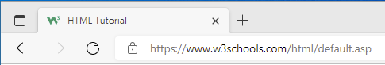
To add a favicon to your website, either save your favicon image to the root directory of your webserver, or create a folder in the root directory called images, and save your favicon image in this folder. A common name for a favicon image is "favicon.ico".
Next, add a <link> element to your "index.html" file, after the <title> element, like this:

Example
<!DOCTYPE html>
<html>
<head>
<title>My Page Title</title>
<link rel="icon" type="image/x-icon" href="/images/favicon.ico">
</head>
<body>
<h1>This is a Heading</h1>
<p>This is a paragraph.</p>
</body>
</html>

Favicon File Format Support
The following table shows the file format support for a favicon image:
Browser | ICO | PNG | GIF | JPEG | SVG
Edge | Yes | Yes | Yes | Yes | Yes
Chrome | Yes | Yes | Yes | Yes | Yes
Firefox | Yes | Yes | Yes | Yes | Yes
Opera | Yes | Yes | Yes | Yes | Yes
Safari | Yes | Yes | Yes | Yes | Yes

Chapter Summary
- Use the HTML <link> element to insert a favicon

HTML Link Tag
Tag | Description
<link> | Defines the relationship between a document and an external resource

  - Tables

HTML Tables
HTML tables allow web developers to arrange data into rows and columns.

Example
Company | Contact | Country
Alfreds Futterkiste | Maria Anders | Germany
Centro comercial Moctezuma | Francisco Chang | Mexico
Ernst Handel | Roland Mendel | Austria
Island Trading | Helen Bennett | UK
Laughing Bacchus Winecellars | Yoshi Tannamuri | Canada
Magazzini Alimentari Riuniti | Giovanni Rovelli | Italy

Define an HTML Table
A table in HTML consists of table cells inside rows and columns.

Example
A simple HTML table:
<table>
<tr>
<th>Company</th>
<th>Contact</th>
<th>Country</th>
</tr>
<tr>
<td>Alfreds Futterkiste</td>
<td>Maria Anders</td>
<td>Germany</td>
</tr>
<tr>
<td>Centro comercial Moctezuma</td>
<td>Francisco Chang</td>
<td>Mexico</td>
</tr>
</table>

Table Cells
Each table cell is defined by a <td> and a </td> tag.
td stands for table data.
Everything between <td> and </td> are the content of the table cell.

Example
<table>
<tr>
<td>Emil</td>
<td>Tobias</td>
<td>Linus</td>
</tr>
</table>
Note: A table cell can contain all sorts of HTML elements: text, images, lists, links, other tables, etc.

OUTPUT
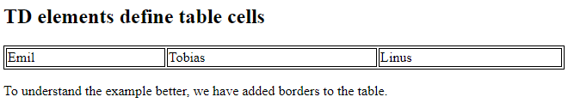

Table Rows
Each table row starts with a <tr> and ends with a </tr> tag.
tr stands for table row.

Example
<table>
<tr>
<td>Emil</td>
<td>Tobias</td>
<td>Linus</td>
</tr>
<tr>
<td>16</td>
<td>14</td>
<td>10</td>
</tr>
</table>
OUTPUT
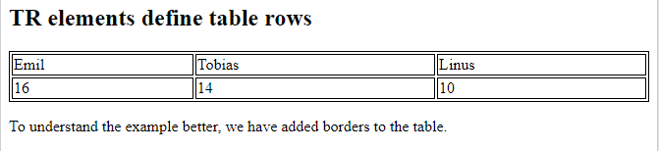
You can have as many rows as you like in a table; just make sure that the number of cells are the same in each row.
Note: There are times when a row can have less or more cells than another. You will learn about that in a later chapter.

Table Headers
Sometimes you want your cells to be table header cells. In those cases use the <th> tag instead of the <td> tag:
th stands for table header.

Example
Let the first row be table header cells:
<table>
<tr>
<th>Person 1</th>
<th>Person 2</th>
<th>Person 3</th>
</tr>
<tr>
<td>Emil</td>
<td>Tobias</td>
<td>Linus</td>
</tr>
<tr>
<td>16</td>
<td>14</td>
<td>10</td>
</tr>
</table>
OUTPUT
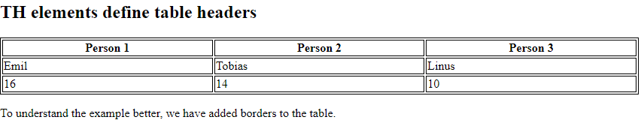
By default, the text in <th> elements are bold and centered, but you can change that with CSS.
HTML tables can have borders of different styles and shapes.

How To Add a Border
When you add a border to a table, you also add borders around each table cell:
To add a border, use the CSS border property on table, th, and td elements:

Example
table, th, td {
border: 1px solid black;
}

Collapsed Table Borders
To avoid having double borders like in the example above, set the CSS border-collapse property to collapse.
This will make the borders collapse into a single border:

Example
table, th, td {
border: 1px solid black;
border-collapse: collapse;
}

Style Table Borders
If you set a background color of each cell, and give the border a white color (the same as the document background), you get the impression of an invisible border:

Example
table, th, td {
border: 1px solid white;
border-collapse: collapse;
}
th, td {
background-color: #96D4D4;
}

Round Table Borders
With the border-radius property, the borders get rounded corners:
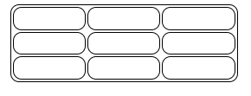

Example
table, th, td {
border: 1px solid black;
border-radius: 10px;
}
Skip the border around the table by leaving out table from the css selector:
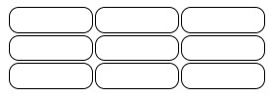

Example
th, td {
border: 1px solid black;
border-radius: 10px;
}

Border Color
With the border-color property, you can set the color of the border.
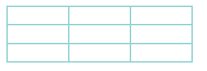

Example
th, td {
border-color: #96D4D4;
}

HTML Table Width
To set the width of a table, add the style attribute to the <table> element:

HTML Table Column Width
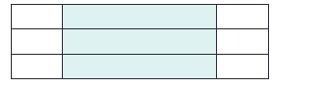
To set the size of a specific column, add the style attribute on a <th> or <td> element:

Example
Set the width of the first column to 70%:
<table style="width:100%">
<tr>
<th style="width:70%">Firstname</th>
<th>Lastname</th>
<th>Age</th>
</tr>
<tr>
<td>Jill</td>
<td>Smith</td>
<td>50</td>
</tr>
<tr>
<td>Eve</td>
<td>Jackson</td>
<td>94</td>
</tr>
</table>

HTML Table Padding & Spacing
HTML tables can adjust the padding inside the cells, and also the space between the cells.
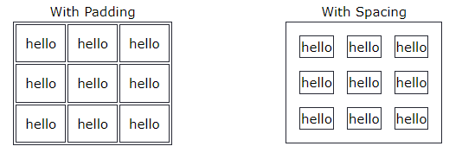

HTML Table - Cell Padding
Cell padding is the space between the cell edges and the cell content.
By default the padding is set to 0.
To add padding on table cells, use the CSS padding property:

Example
th, td {
padding: 15px;
}
To add padding only above the content, use the padding-top property.
And the others sides with the padding-bottom, padding-left, and padding-right properties:

Example
th, td {
padding-top: 10px;
padding-bottom: 20px;
padding-left: 30px;
padding-right: 40px;
}

HTML Table - Cell Spacing
Cell spacing is the space between each cell.
By default the space is set to 2 pixels.
To change the space between table cells, use the CSS border-spacing property on the table element:

Example
table {
border-spacing: 30px;
}

HTML Table Colspan & Rowspan
HTML tables can have cells that span over multiple rows and/or columns.

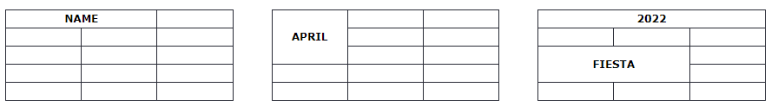
HTML Table - Colspan
To make a cell span over multiple columns, use the colspan attribute:

Example
<table>
<tr>
<th colspan="2">Name</th>
<th>Age</th>
</tr>
<tr>
<td>Jill</td>
<td>Smith</td>
<td>43</td>
</tr>
<tr>
<td>Eve</td>
<td>Jackson</td>
<td>57</td>
</tr>
</table>
Note: The value of the colspan attribute represents the number of columns to span.
OUTPUT
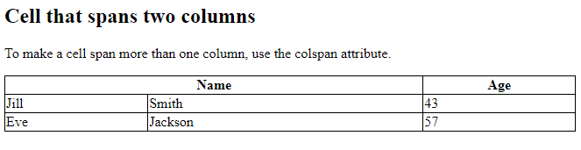

HTML Table - Rowspan
To make a cell span over multiple rows, use the rowspan attribute:

Example
<table>
<tr>
<th>Name</th>
<td>Jill</td>
</tr>
<tr>
<th rowspan="2">Phone</th>
<td>555-1234</td>
</tr>
<tr>
<td>555-8745</td>
</tr>
</table>
OUTPUT

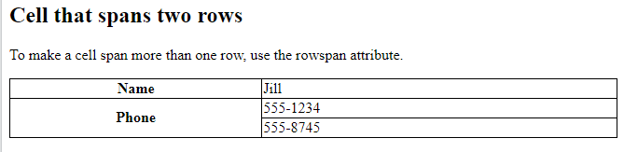

  - Lists

HTML Lists
HTML lists allow web developers to group a set of related items in lists.

Example
An unordered HTML list:
- Item
- Item
- Item
- Item
An ordered HTML list:
- First item
- Second item
- Third item
- Fourth item
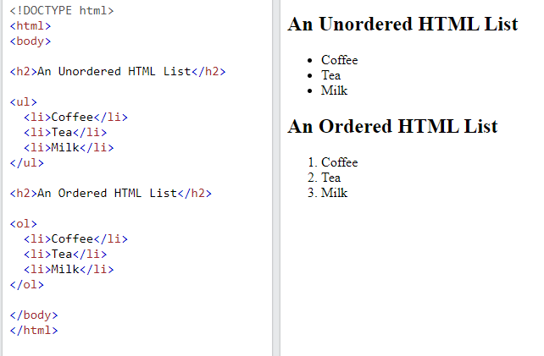

Unordered HTML List
An unordered list starts with the <ul> tag. Each list item starts with the <li> tag.
The list items will be marked with bullets (small black circles) by default:

Example
<ul>
<li>Coffee</li>
<li>Tea</li>
<li>Milk</li>
</ul>

Ordered HTML List
An ordered list starts with the <ol> tag. Each list item starts with the <li> tag.
The list items will be marked with numbers by default:

Example
<ol>
<li>Coffee</li>
<li>Tea</li>
<li>Milk</li>
</ol>

HTML Description Lists
HTML also supports description lists.
A description list is a list of terms, with a description of each term.
The <dl> tag defines the description list, the <dt> tag defines the term (name), and the <dd> tag describes each term:

Example
<dl>
<dt>Coffee</dt>
<dd>- black hot drink</dd>
<dt>Milk</dt>
<dd>- white cold drink</dd>
</dl>

Chapter Summary
- Use the HTML <dl> element to define a description list
- Use the HTML <dt> element to define the description term
- Use the HTML <dd> element to describe the term in a description list

  - block and inline

HTML Block and Inline Elements
Every HTML element has a default display value, depending on what type of element it is.
There are two display values: block and inline.

Block-level Elements
A block-level element always starts on a new line, and the browsers automatically add some space (a margin) before and after the element.
A block-level element always takes up the full width available (stretches out to the left and right as far as it can).
Two commonly used block elements are: <p> and <div>.
The <p> element defines a paragraph in an HTML document.
The <div> element defines a division or a section in an HTML document.
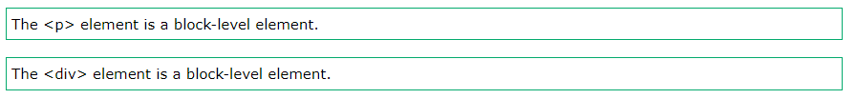

Example
<p>Hello World</p>
<div>Hello World</div>
Here are the block-level elements in HTML:

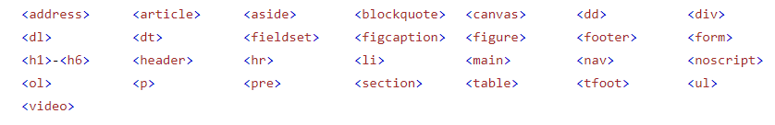

Inline Elements
An inline element does not start on a new line.
An inline element only takes up as much width as necessary.
This is a <span> element inside a paragraph.

Example
<span>Hello World</span>
Here are the inline elements in HTML:
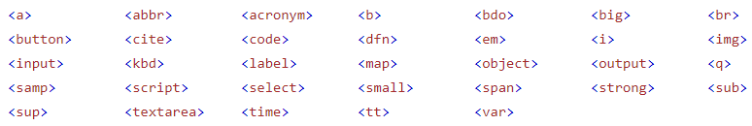

The <div> Element
The <div> element is often used as a container for other HTML elements.
The <div> element has no required attributes, but style, class and id are common.
When used together with CSS, the <div> element can be used to style blocks of content:

Example
<div style="background-color:black;color:white;padding:20px;">
<h2>London</h2>
<p>London is the capital city of England. It is the most populous city in the United Kingdom, with a metropolitan area of over 13 million inhabitants.</p>
</div>

The <span> Element
The <span> element is an inline container used to mark up a part of a text, or a part of a document.
The <span> element has no required attributes, but style, class and id are common.
When used together with CSS, the <span> element can be used to style parts of the text:

Example
<p>My mother has <span style="color:blue;font-weight:bold;">blue</span> eyes and my father has <span style="color:darkolivegreen;font-weight:bold;">dark green</span> eyes.</p>

Chapter Summary
- There are two display values: block and inline
- A block-level element always starts on a new line and takes up the full width available
- An inline element does not start on a new line and it only takes up as much width as necessary
- The <div> element is a block-level and is often used as a container for other HTML elements
- The <span> element is an inline container used to mark up a part of a text, or a part of a document

  - Classes

HTML class Attribute
The HTML class attribute is used to specify a class for an HTML element.
Multiple HTML elements can share the same class.

Using The class Attribute
The class attribute is often used to point to a class name in a style sheet. It can also be used by a JavaScript to access and manipulate elements with the specific class name.
In the following example we have three <div> elements with a class attribute with the value of "city". All of the three <div> elements will be styled equally according to the .city style definition in the head section:

Example
<!DOCTYPE html>
<html>
<head>
<style>
.city {
background-color: tomato;
color: white;
border: 2px solid black;
margin: 20px;
padding: 20px;
}
</style>
</head>
<body>
<div class="city">
<h2>London</h2>
<p>London is the capital of England.</p>
</div>
<div class="city">
<h2>Paris</h2>
<p>Paris is the capital of France.</p>
</div>
<div class="city">
<h2>Tokyo</h2>
<p>Tokyo is the capital of Japan.</p>
</div>
</body>
</html>
In the following example we have two <span> elements with a class attribute with the value of "note". Both <span> elements will be styled equally according to the .note style definition in the head section:

Example
<!DOCTYPE html>
<html>
<head>
<style>
.note {
font-size: 120%;
color: red;
}
</style>
</head>
<body>
<h1>My <span class="note">Important</span> Heading</h1>
<p>This is some <span class="note">important</span> text.</p>
</body>
</html>

Tip: The class attribute can be used on any HTML element.
Note: The class name is case sensitive!

The Syntax For Class
To create a class; write a period (.) character, followed by a class name. Then, define the CSS properties within curly braces {}:

Example
Create a class named "city":
<!DOCTYPE html>
<html>
<head>
<style>
.city {
background-color: tomato;
color: white;
padding: 10px;
}
</style>
</head>
<body>
<h2 class="city">London</h2>
<p>London is the capital of England.</p>
<h2 class="city">Paris</h2>
<p>Paris is the capital of France.</p>
<h2 class="city">Tokyo</h2>
<p>Tokyo is the capital of Japan.</p>
</body>
</html>

Multiple Classes
HTML elements can belong to more than one class.
To define multiple classes, separate the class names with a space, e.g. <div class="city main">. The element will be styled according to all the classes specified.
In the following example, the first <h2> element belongs to both the city class and also to the main class, and will get the CSS styles from both of the classes:

Example
<h2 class="city main">London</h2>
<h2 class="city">Paris</h2>
<h2 class="city">Tokyo</h2>

Different Elements Can Share Same Class
Different HTML elements can point to the same class name.
In the following example, both <h2> and <p> point to the "city" class and will share the same style:

Example
<h2 class="city">Paris</h2>
<p class="city">Paris is the capital of France</p>

Use of The class Attribute in JavaScript
The class name can also be used by JavaScript to perform certain tasks for specific elements.
JavaScript can access elements with a specific class name with the getElementsByClassName() method:

Example
Click on a button to hide all elements with the class name "city":
<script>
function myFunction() {
var x = document.getElementsByClassName("city");
for (var i = 0; i < x.length; i++) {
x[i].style.display = "none";
}
}
</script>

Chapter Summary
- The HTML class attribute specifies one or more class names for an element
- Classes are used by CSS and JavaScript to select and access specific elements
- The class attribute can be used on any HTML element
- The class name is case sensitive
- Different HTML elements can point to the same class name
- JavaScript can access elements with a specific class name with the getElementsByClassName() method

  - file paths

HTML File Paths
A file path describes the location of a file in a web site's folder structure.

File Path Examples
Path | Description
<img src="picture.jpg"> | The "picture.jpg" file is located in the same folder as the current page
<img src="images/picture.jpg"> | The "picture.jpg" file is located in the images folder in the current folder
<img src="/images/picture.jpg"> | The "picture.jpg" file is located in the images folder at the root of the current web
<img src="../picture.jpg"> | The "picture.jpg" file is located in the folder one level up from the current folder

HTML File Paths
A file path describes the location of a file in a web site's folder structure.
File paths are used when linking to external files, like:
- Web pages
- Images
- Style sheets
- JavaScripts

Absolute File Paths
An absolute file path is the full URL to a file:

Example
<img src="https://www.w3schools.com/images/picture.jpg" alt="Mountain">

Relative File Paths
A relative file path points to a file relative to the current page.
In the following example, the file path points to a file in the images folder located at the root of the current web:

Example
<img src="/images/picture.jpg" alt="Mountain">
In the following example, the file path points to a file in the images folder located in the folder one level up from the current folder:

Example
<img src="../images/picture.jpg" alt="Mountain">

Best Practice
It is best practice to use relative file paths (if possible).
When using relative file paths, your web pages will not be bound to your current base URL. All links will work on your own computer (localhost) as well as on your current public domain and your future public domains.
  - Layout

HTML Layout Elements and Techniques
Websites often display content in multiple columns (like a magazine or a newspaper).
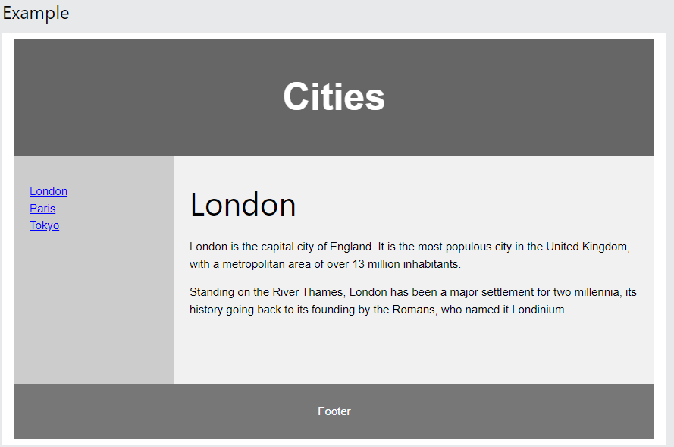

HTML Layout Elements
HTML has several semantic elements that define the different parts of a web page:
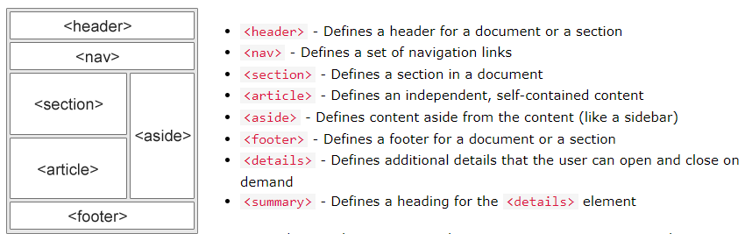

HTML Layout Techniques
There are four different techniques to create multicolumn layouts. Each technique has its pros and cons:
- CSS framework
- CSS float property
- CSS flexbox
- CSS grid

CSS Float Layout
It is common to do entire web layouts using the CSS float property. Float is easy to learn - you just need to remember how the float and clear properties work. Disadvantages: Floating elements are tied to the document flow, which may harm the flexibility. Learn more about float in our CSS Float and Clear chapter.

Example
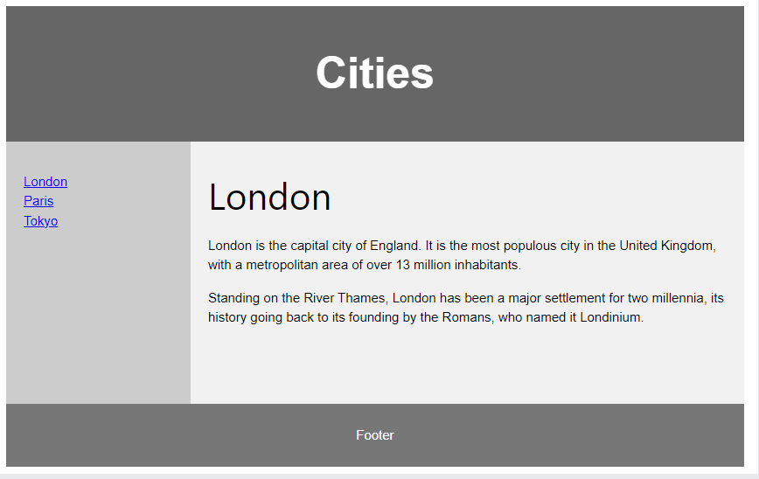

<!DOCTYPE html>
<html lang="en">
<head>
<title>CSS Template</title>
<meta charset="utf-8">
<meta name="viewport" content="width=device-width, initial-scale=1">
<style>
* {
box-sizing: border-box;
}

body {
font-family: Arial, Helvetica, sans-serif;
}

/* Style the header */
header {
background-color: #666;
padding: 30px;
text-align: center;
font-size: 35px;
color: white;
}

/* Create two columns/boxes that floats next to each other */
nav {
float: left;
width: 30%;
height: 300px; /* only for demonstration, should be removed */
background: #ccc;
padding: 20px;
}

/* Style the list inside the menu */
nav ul {
list-style-type: none;
padding: 0;
}

article {
float: left;
padding: 20px;
width: 70%;
background-color: #f1f1f1;
height: 300px; /* only for demonstration, should be removed */
}

/* Clear floats after the columns */
section::after {
content: "";
display: table;
clear: both;
}

/* Style the footer */
footer {
background-color: #777;
padding: 10px;
text-align: center;
color: white;
}

/* Responsive layout - makes the two columns/boxes stack on top of each other instead of next to each other, on small screens */
@media (max-width: 600px) {
nav, article {
width: 100%;
height: auto;
}
}
</style>
</head>
<body>

<h2>CSS Layout Float</h2>
<p>In this example, we have created a header, two columns/boxes and a footer. On smaller screens, the columns will stack on top of each other.</p>
<p>Resize the browser window to see the responsive effect (you will learn more about this in our next chapter - HTML Responsive.)</p>

<header>
<h2>Cities</h2>
</header>

<section>
<nav>
<ul>
<li><a href="#">London</a></li>
<li><a href="#">Paris</a></li>
<li><a href="#">Tokyo</a></li>
</ul>
</nav>

<article>
<h1>London</h1>
<p>London is the capital city of England. It is the most populous city in the United Kingdom, with a metropolitan area of over 13 million inhabitants.</p>
<p>Standing on the River Thames, London has been a major settlement for two millennia, its history going back to its founding by the Romans, who named it Londinium.</p>
</article>
</section>

<footer>
<p>Footer</p>
</footer>

</body>
</html>

  - Responsive

HTML Responsive Web Design
Responsive web design is about creating web pages that look good on all devices!
A responsive web design will automatically adjust for different screen sizes and viewports.
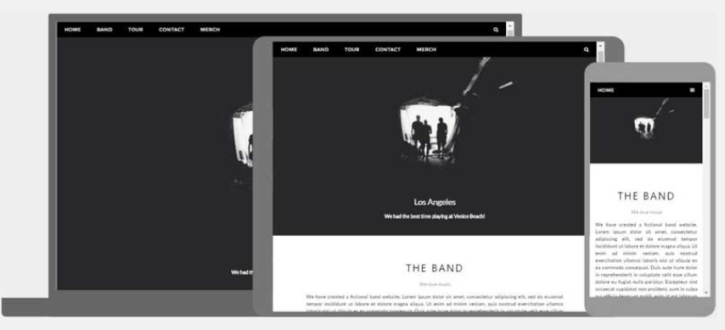

What is Responsive Web Design?
Responsive Web Design is about using HTML and CSS to automatically resize, hide, shrink, or enlarge, a website, to make it look good on all devices (desktops, tablets, and phones):

Setting The Viewport
To create a responsive website, add the following <meta> tag to all your web pages:

Example
<meta name="viewport" content="width=device-width, initial-scale=1.0">
This will set the viewport of your page, which will give the browser instructions on how to control the page's dimensions and scaling.
Here is an example of a web page without the viewport meta tag, and the same web page with the viewport meta tag:

Responsive Images
Responsive images are images that scale nicely to fit any browser size.

Using the width Property
If the CSS width property is set to 100%, the image will be responsive and scale up and down:

Example
<img src="img_girl.jpg" style="width:100%;">

Using the max-width Property
If the max-width property is set to 100%, the image will scale down if it has to, but never scale up to be larger than its original size:

Example
<img src="img_girl.jpg" style="max-width:100%;height:auto;">

Show Different Images Depending on Browser Width
The HTML <picture> element allows you to define different images for different browser window sizes.
Resize the browser window to see how the image below changes depending on the width:

Example
<picture>
<source srcset="img_smallflower.jpg" media="(max-width: 600px)">
<source srcset="img_flowers.jpg" media="(max-width: 1500px)">
<source srcset="flowers.jpg">
<img src="img_smallflower.jpg" alt="Flowers">
</picture>

Responsive Text Size
The text size can be set with a "vw" unit, which means the "viewport width".
That way the text size will follow the size of the browser window:

Hello World
Resize the browser window to see how the text size scales.

Example
<h1 style="font-size:10vw">Hello World</h1>

Media Queries
In addition to resize text and images, it is also common to use media queries in responsive web pages.
With media queries you can define completely different styles for different browser sizes.
Example: resize the browser window to see that the three div elements below will display horizontally on large screens and stack vertically on small screens:

Example
<style>
.left, .right {
float: left;
width: 20%; /* The width is 20%, by default */
}
.main {
float: left;
width: 60%; /* The width is 60%, by default */
}
/* Use a media query to add a breakpoint at 800px: */
@media screen and (max-width: 800px) {
.left, .main, .right {
width: 100%; /* The width is 100%, when the viewport is 800px or smaller */
}
}
</style>

